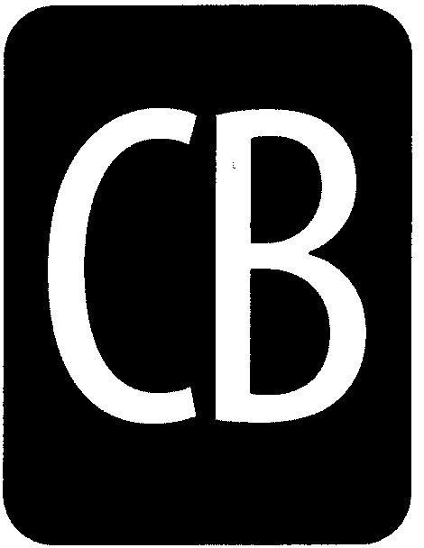

# CENTRAL BUCKS SCHOOL DISTRICT

## LEADING THE WAY

The Central Bucks Schools will provide all students with the academic and problem-solving skills  
essential for personal development, responsible citizenship, and life-long learning.

**PA Medical Assistance (MA) Billing Parental Consent Form**

I understand that:

1. Central Bucks School District is eligible to receive federal reimbursement through the School-Based Access Program for certain medically necessary services provided to students with disabilities ages 3-21 in accordance with the students’ IEP.
2. Central Bucks School District’s use of this reimbursement program does NOT in any way affect or impact other medically necessary, covered services that are provided to your child out of school. Medical Assistance will continue to pay for these services. Any reimbursement that the Central Bucks School District receives from the School-Based Access program is used to help cover the cost of special education services.
3. Before Central Bucks School District can apply for reimbursement for services, a one-time written parental consent is required by The Individuals with Disabilities Education Improvement Act of 2004 (IDEA) under Part 300 (Assistance to the States for the Education of Children with Disabilities) and the Family Educational Rights and Privacy Act (FERPA).
4. By giving consent, I am authorizing Central Bucks School District to share my child’s information such as records or information about the services that may be provided to my child with the PA Department of Education, the PA Department of Public Welfare, and a physician or nurse practitioner in order to bill Medical Assistance for services my child receives as part of his/her IEP. The only purpose of this disclosure is to bill for services provided.
5. I have the right to withdraw my consent at any time. Withdrawing my consent or not giving consent, will not affect the services that my child is receiving in school. It is still the responsibility of Central Bucks School District to provide my child’s required services as written in his/her Individual education Plan at no cost to me.
6. Upon request, I may receive copies of my child’s records that are disclosed as a result of this authorization.

_____ I have read the Notice and I give consent for Central Bucks School District to share my child’s education and health-related information and bill Medical Assistance.

Parent/Guardian Signature ______________________________________________________

Student’s Full Name____________________________________________________________

Date of Birth____________________________ Date _______________________________

Name of School _______________________________________________________________

***\* Any questions should be directed to Doreen Erato-Sharp at 267.893.2030 or derato@cbsd.org***